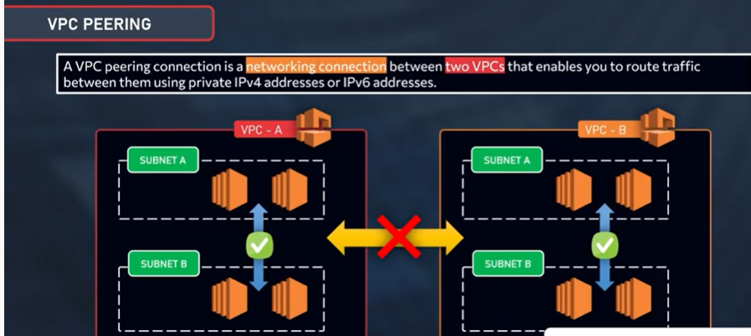



Inter region VPC connections

A VPC peering connection is a networking connection between two VPCs that enables you to route traffic between them using private IPv4 addresses or IPv6 addresses. Instances in either VPC can communicate with each other as if they are within the same network. You can create a VPC peering connection between your own VPCs, or with a VPC in another AWS account. The VPCs can be in different regions (also known as an inter-region VPC peering connection).

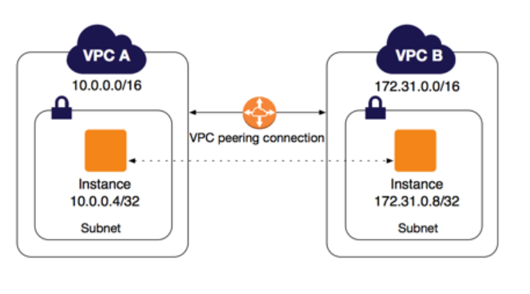

Create two VPC

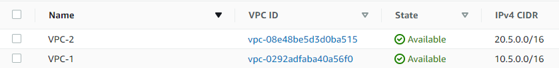

Launch Ec2 instance from two VPC’s

